**EX NO.: 05 PL/SQL**

**AIM:**

To work with PL/SQL commands

**PROCEDURE:**

Step1: Open Run SQL on Command line and connect to SQL .

Step 2: Then work with database using PL/SQL Block commands

1. Declare
2. Begin
3. Exception
4. End

**SYNTAX:**

DECLARE

<declarations section>

BEGIN

<executable command(s)>

EXCEPTION

<exception handling>

END;

**EXAMPLE:**

1. **ADDITION OF TWO NUMBERS:**

**PROGRAM CODE:**

SQL> SET SERVEROUTPUT ON;

SQL> declare

2 x number(5);

3 y number(5);

4 z number(5);

5 begin

6 x:=50;

7 y:=20;

8 z:=x+y;

9 dbms_output.put_line('sum is'||z);

10 end;

11 /

**OUTPUT:**

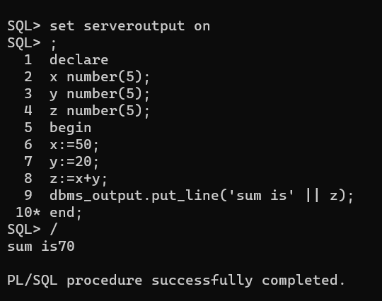

1. **GENERATING SERIES:**

**PROGRAM CODE:**

SQL> SET SERVEROUTPUT ON;

SQL> declare

2 n number(5);

3 tempp number(5);

4 begin

5 n:=1; --1 for print first 10 numbers,2 for even number,3 for odd

6 for i in 1..10 loop

7 case n

8 when 1 then

9 dbms_output.put_line(i);

10 when 2 then

11 if mod(i,2)=0 then

12 dbms_output.put_line(i);

13 end if;

14 when 3 then

15 if mod(i,2)!=0 then

16 dbms_output.put_line(i);

17 end if;

18 end case;

19 end loop;

20 end;

21 /

**OUTPUT:**

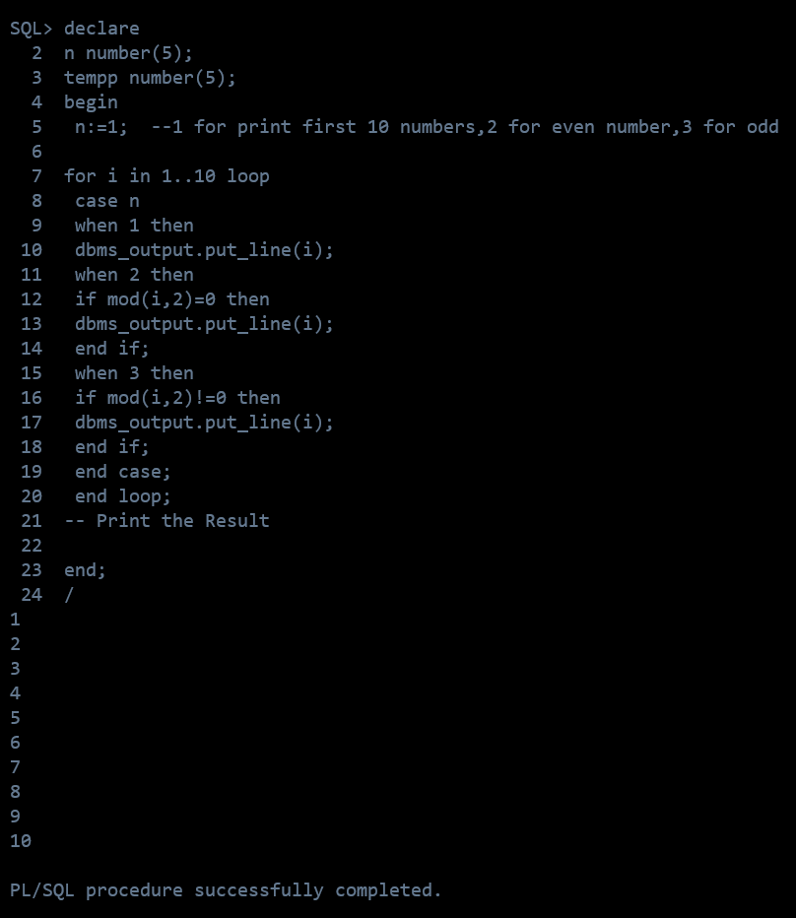

**RESULT:**

The PL/SQL queries were successfully executed and the output is noted.